Phrase/ Sentence that stands out | Why I like it | How it makes me feel | Author’s Craft

Author’s Purpose and Voice Planning Chart
Audience (who will read this?): | Message (what am I trying to express?) | Purpose (why did I write this?)  - Persuade  - Inform  - Entertain  about/ because…
Author’s Craft Strategy: | Paragraph/ Idea | Author’s Craft/ Voice Sentence to Add:

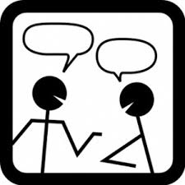  Dialogue  A conversation between two or more people.  “I’m uncomfortable with that decision.” John told her.  “Pleeaaassseee?” She begged in return. | 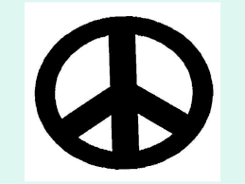  Symbolism  Definition: When a special meaning is given to an object; Objects that represent ideas or qualities  This is more than a locket, it’s a symbol of my love for you.
  Tone / Mood  The author or narrator’s feelings as revealed by word choice and provided information.  The words “She yelled for them to stop because she felt mistreated” sets a tone of anger and frustration. | 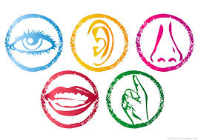  Sensory Detail  Specific descriptive words telling how something looks, smells, tastes, feels, or sounds.  As she licked her lips, she could taste the brown sugar and butter used to make the caramel.
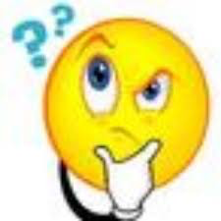  Interesting words  Words that stand out as meaningful or impactful in a text.  “If you’d given me a room full of sober Indians, crying and laughing and telling stories, then I would have stayed.” | 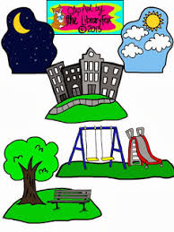  Description  Words that provide specific detail about a character, the setting, an object or event.  Her long brown hair fell over her shoulders and hid her eyes as tears dripped down her face.
  Repetition  When a word or phrase is used multiple times | 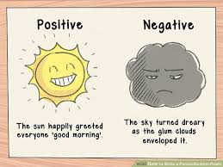  Personification  A figure of speech in which an object or animal is given human feelings, thoughts, or attitudes.  The sun happily greeted everyone ‘good morning’.
  Text features  Parts of a text that add information through a visual element  Charts, graphs, pictures, tables, bold or italicized words, headings |   Metaphor  A comparison without using like or as.  Happiness is the key to success.
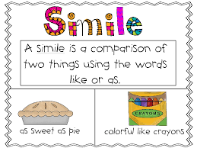  Simile  A comparison using like or as.  She is as sweet as pie. | 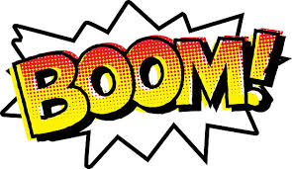  Onomatopoeia  Words that tell how something sounds.  “Ring” “Meow”
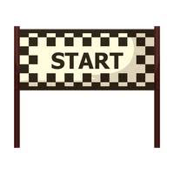  Bold beginning  A strong opening that catches attention through the use of words |   Powerful end  A meaningful ending that makes the reader think deeply based on the use of words
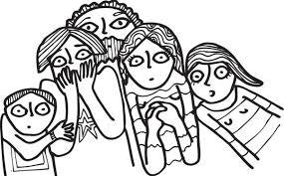  Suspense  Words that create a feeling of excitement to find out what will happen next.  Tarzan’s love, Jane, is carried away by a giant ape. Jane asks “How can anyone get rid of such a mighty villain.” This tells the reader Jane thinks Tarzan will not be able to save her, causing suspense. | 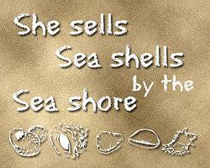  Alliteration  The repetition of initial consonant sounds

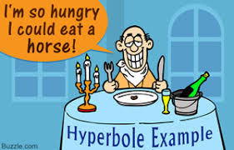  Hyperbole  An extreme exaggeration. | 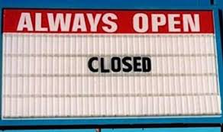  Irony  The expression of meaning using words that normally mean the opposite, usually for humor
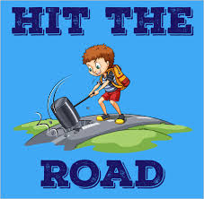  Idiom  A common saying used to express an idea | 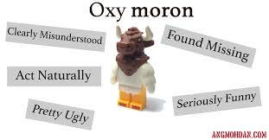  Oxymoron  The pairing of words that hold opposite meaning.
  Statistic  A quantity or number that reveals specific information  “Nearly 18% of Americans eat fish daily.” | 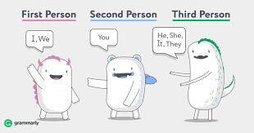  Point of view  The point from which a story is viewed  The way a character feels determined through thoughts, actions, and words.
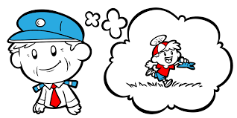  Flashback  The description of an event that took place earlier than the rest of the story.  I remembered when it all started. Our house was nothing but a series of screaming then weeping, over and over again. | 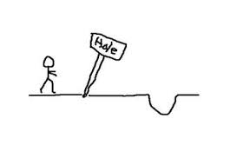  Foreshadowing  Hints provided to assist readers in predicting what will happen next.  He said if anyone ever beat him again, he’d kill them.

